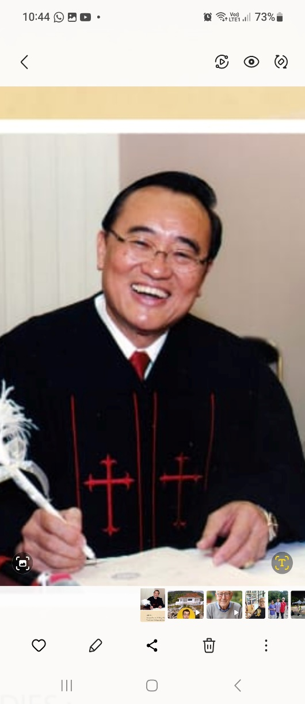Speaker

Rev. Loh Wah Meng

Whom I worked with in Penang in 1977 when he directed the Here’s Life I Found It campaign will be moving back to Malaysia in 2024 from Hong Kong to join as teaching staff in Capernwray Malaysia, Harvest Haven. He left Malaysia with his family to study in the Dallas Theological Seminary in Texas in 1985 for his Master of Theology degree. Sensing the need to strengthen the church leaders in Hong Kong to face 1997, Rev. Loh and his family then went to Hong Kong in 1992 and stayed there for 31 years. He is a Pastor, Teacher and Leader, greatly used by God. Come spend the weekend with them to welcome them home!

**Date: January 26-28, 2024 (Friday to Sunday)**

**Venue: Harvest Haven, Gopeng**

**Theme: FIRST PETER** – “Living Hope in Turbulent Times”

**Cost: RM200 per participant nett (4 to 8 persons room)**

**RM 250 per participant nett (2 person double room)**

**Registration:**

Name: Mr./Mrs.______________________________H/P:_________

Address: _________________________________________________

Accommodation: RM200_______RM250_______ (please tick)

Church Affiliation:_________________________________________

**Organized by Capernwray (M) Sdn. Bhd.**

**Please register early to help us plan.**

**First Peter - synopsis**

Living in times of sufferings, hostilities, oppositions, persecutions, animosities even wars, the tough fisherman, the Apostle Peter wrote to give us confidence, encouragement, strength, hope as he did to the believers who suffered under the despotic ruler Nero of his time. We can transform our mind to that of our Lord and His will so we could live faithfully and victoriously regardless of our circumstances.

Program:

|  |  |  |  |
| --- | --- | --- | --- |
|  | Friday 26 | Saturday 27 | Sunday 28 |
| 7.30 - 8.00am |  | Rise and Shine | Rise and Shine |
| 8.00 – 8.30 |  | Quiet Time | Quiet Time |
| 8.30 – 9.30 |  | Breakfast | Breakfast |
| 9.30 – 11.00 |  | Session 2 | Session 4 – Worship and Lord’s Supper |
| 11.00 – 12.30pm |  | Tea break and Fellowship | Tea break and Fellowship |
| 12.30 – 1.30 |  | Lunch | Lunch |
| 1.30 – 6.30 | Registration | Free time | Home Sweet Home! |
| 6.30 – 7.30 | Dinner | Dinner |  |
| 7.30 – 9.00 | Session 1 | Session 3 |  |
| 9.00 – 10.30 | Tea & Fellowship | Tea & Fellowship |  |
| 11.00 pm | Lights Out | Lights Out |  |

SESSION 1 = “BE HAPPY AS WE SUFFER = NO DEPRESSION”

SESSION 2 = “BE STRONG AS WE GROW UP AND FEEL BLESSED”

SESSION 3 = “WHAT’S WRONG WITH YOU?”

SESSION 4 = WORSHIP SERVICE WITH THE LORD’S SUPPER –

“CONTINUE OUR MINISTRIES. WE HAVE SUCCESS, IT IS GRACE.”

For more information:

Contact: John Lee – 012 4884708 / David Chong – 012 2642015

Steven Tong – 011 36123712